**273/2**

**GEOGRAPHY**

**Paper 2**

**Jul./Aug. 2019**

**2½ Hours**



**UTEB JOINT MOCK EXAMINATIONS, 2019**

**Uganda Certificate of Education**

GEOGRAPHY

**Paper 2**

2 hours 30 minutes

**INSTRUCTIONS TO CANDIDATES**

* Answer **four** questions only.
* Choose **two** questions from Part **I** and two from Part **II**.
* In Part **II**, only **one** question should be chosen from any **one** region.
* Any additional question(s) answered will **not** be marked.

**Turn Over**

**PART I: THE REST OF AFRICA**

Answer **two** questions from this part.

1. Study table 1 below showing the climate of station A and answer the questions that follow;

**Table 1: Climate of station A** (altitude 1.500m)

|  |  |  |  |  |  |  |  |  |  |  |  |  |
| --- | --- | --- | --- | --- | --- | --- | --- | --- | --- | --- | --- | --- |
| **Month** | **J** | **F** | **M** | **A** | **M** | **J** | **J** | **A** | **S** | **O** | **N** | **D** |
| Temp0C | 24 | 23 | 22 | 21 | 20 | 18 | 17 | 18 | 20 | 23 | 24 | 24 |
| Rainfall (mm) | 200 | 175 | 100 | 25 | 20 | - | - | - | - | 50 | 100 | 175 |

*Source :* ***Minns. W.J A geography of Africa. New edition. P.36***

1. Draw a suitable graph to show the climate of station **A**. **(07 marks)**
2. Calculate the;
3. Total annual rainfall
4. Mean annual rainfall
5. Mean annual temperature  **(06 marks)**
6. Describe the characteristics of the climate experienced at station **A**. **(05 marks)**
7. Explain how climate has influenced agricultural activities around station **A.**

**(06 marks)**

1. (a) Draw a sketch map of South Africa and on it mark and name;
2. **Diamond mining centres**: Pretoria, Kimberly and Port Nolloth
3. **Ports**: Elizabeth and Capetown
4. **Rivers**: Vaal and Orange.  **(08 marks)**

(b) Explain the factors which have favoured the mining of diamonds in the

Republic of South Africa. **(06 marks)**

(c) Describe the methods used in mining of diamonds in South Africa. **(06 marks)**

(d) (i) Outline the problems facing the mining industry in South Africa.

**(03 marks)**

(ii) Suggest solutions to the problems identified in (d) (i) above. **(02 marks)**

1. Study **fig.1** sketch map of West Africa showing areas inhabited by the Fulani and answer the questions that follow:

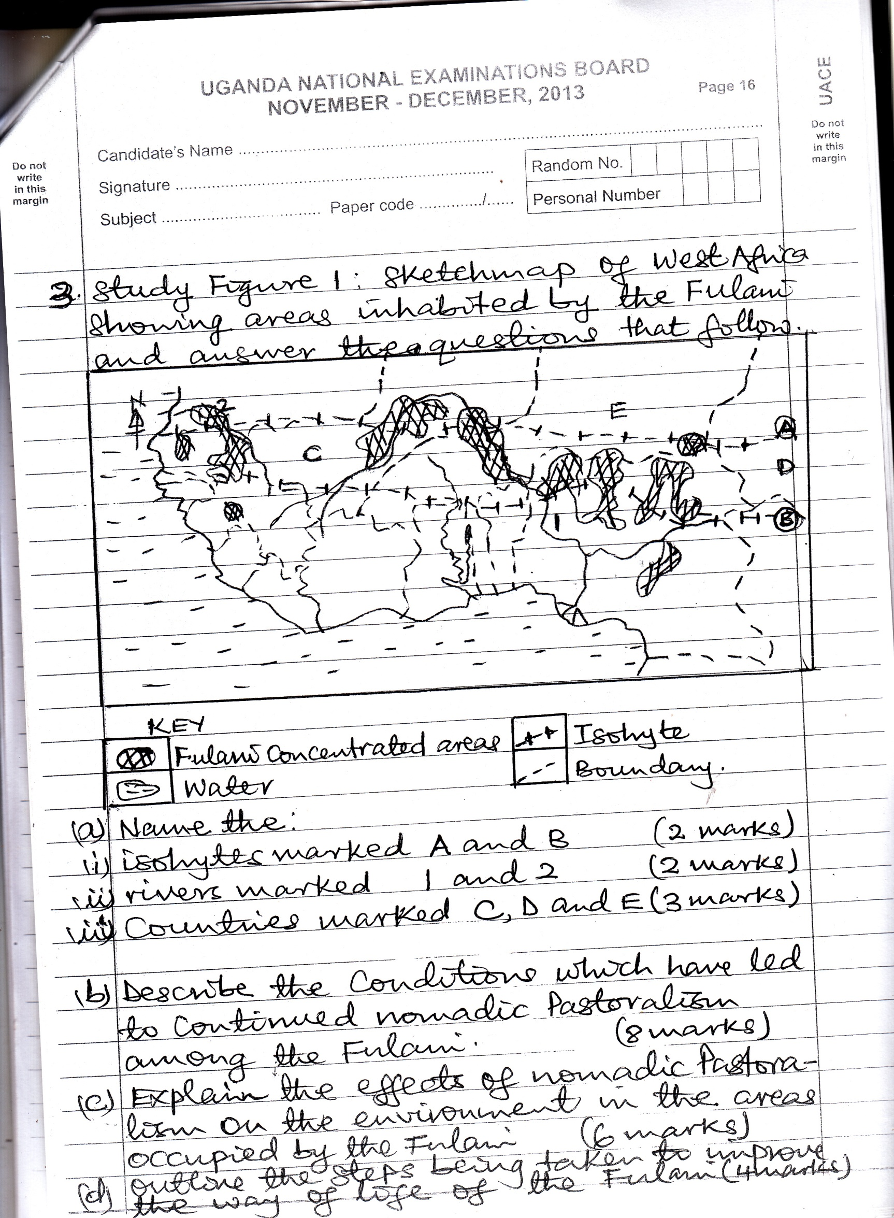

1. Name the;
2. Isohytes marked **A**  and **B.**  **(02 marks)**
3. Rivers marked **1**  and **2**   **(02 marks)**
4. Countries marked **C, D**  and **E.**  **(03 marks)**
5. Describe the conditions which have led to the continued nomadic pastoralism among the Fulani. **(08 marks)**
6. Explain the effects of nomadic patroralism on the environment in the areas occupied by the Fulani. **(06 marks)**
7. Outline the steps being taken to improve the way of life of the Fulani.

**(04 marks)**

1. (a) Draw a sketch map of Africa and on it mark and name;
2. **Ocean currents**: Benguela, Guinea and Canary
3. **Ports**: Dakar and Capetown
4. The three marine fishing grounds; Namibian, West African and Southern Africa coasts. **(09 marks)**

(b) Describe the;

(i) Conditions which have favoured the development of the fishing industry at the Namibian Coast. **(04 marks)**

(ii) Limited the development of commercial fishing at the

West African Coast. **(04 marks)**

(c) Outline the contribution of the fishing industry to Namibia. **(05marks)**

(d) Suggest measures being taken to improve the fishing industry in Namibia.

**(03 marks)**

**PARTII: STUDIES IN DEVELOPMENT**

Answer **two** questions from this part.

**REGION I: NORTH AMERICA**

1. Study figure 2. Sketch map of California and answer the questions that follow:

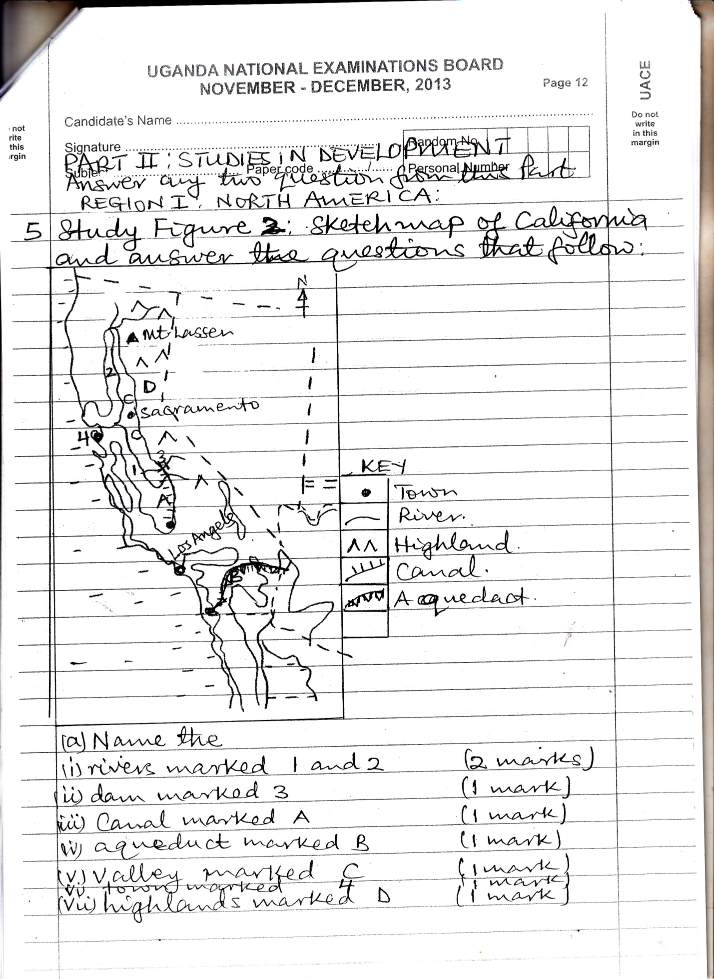

1. Name the;
2. Rivers marked **1**  and **2** **(02 marks)**
3. Dam marked **3** **(01 mark)**
4. Canal marked **A**  **(01 mark)**
5. Aqueduct marked **B.** **(01 mark)**
6. Valley marked **C**  **(01 mark)**
7. Town marked **4** **(01 mark)**
8. Highlands marked **D**  **(01 mark)**
9. Describe the factors which have favoured the development of commercial agriculture in California. **(08 marks)**
10. Explain the effects of commercial agriculture on the environment in California. **(06 marks)**
11. Outline the steps being taken to improve the agricultural sector in California.

**(04 marks)**

1. (a) Draw a sketch map showing the Canadian Prairies and on it mark and name;
2. Ports : Vancouver and Churchill
3. Water bodies: Hudson bay and Atlantic Ocean
4. What production provinces; Alberta, Manitoba and Saskatchewan.

**(08 marks)**

(b) Outline the problems faced by Canadian farmers when exporting

wheat through the;

(i) Western route. **(03 marks)**

(ii) Eastern route **(03 marks)**

(c) Explain the contribution of wheat growing to the development of Canada.

**(06 marks)**

(d) Outline the measures being taken to improve farming on the Canadian

prairies.**(05 marks)**

1. Study the figure below which is a sketch map of New England and use to answer the questions that follow;

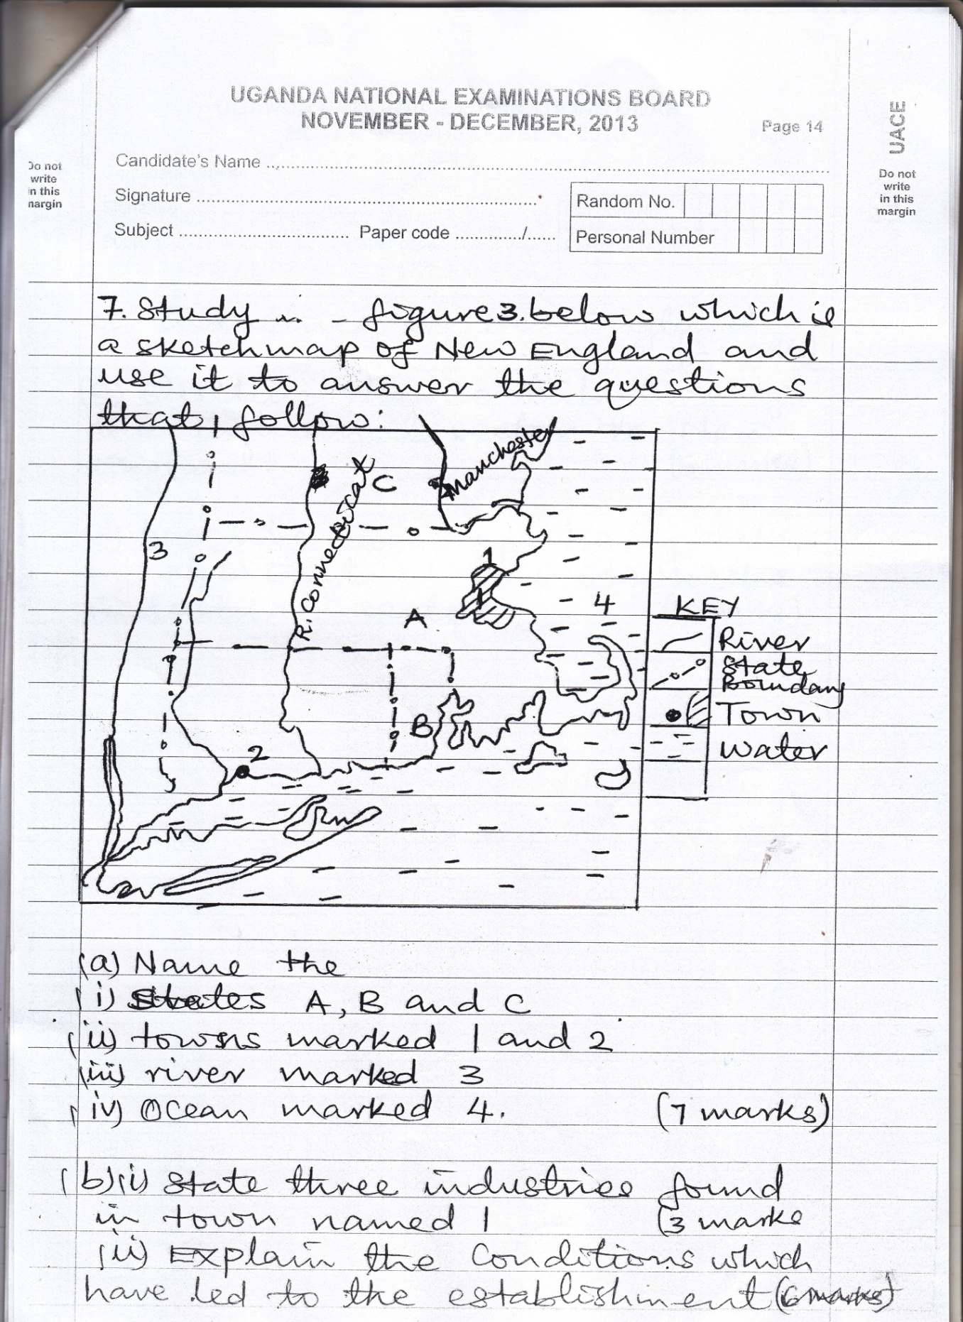

1. Name the;
2. States **A, B**  and **C**
3. Towns marked **1**  and **2**
4. River marked **3**
5. Ocean marked **4**  **(07 marks)**
6. (i) State three industries found in town named **1.****(03 marks)**

(ii) Explain the conditions which have led to the establishment of industries in New England. **(06 marks)**

1. Outline the contribution of the industrial sector to New England. **(05 marks)**
2. Describe the steps being taken by New England to sustain the industrial sector.

**REGION II: RHINELANDS**

1. (a) Draw a sketch map of Luxemburg and on it mark and name;

Areas with : High population density (>150 people km2) moderate population density (50 – 149 people / km2) and low population density (<50 people / km2)

1. **Towns:** Wiltz, Luxembourg and Clervaux.
2. **Rivers:** Sure and Aizette.  **(09 marks)**

(b) Describe the conditions responsible for the population distribution in Luxembourg. **(06 marks)**

(c) Explain the disadvantages of a;

(i) Low population density.

(ii) High population density. **(06 marks)**

(d) Outline the measures being taken to address the population problems in

Luxembourg. **(04 marks)**

1. Study table 2 showing land use types in Belgium and answer the questions which follow:

**Table 2: Land use in Belgium.**

|  |  |
| --- | --- |
| **Land use type** | **Land use area (Hactares)** |
| Arable  Permanent pasture  Forest  Built up / waste land | 939,000  732,000  601,000  779,000 |

1. Calculate the percentage of the land under;
2. Arable
3. Forest
4. Permanent pasture
5. Built up / waste land **(04 marks)**
6. Draw a pie – chart to show the relative importance of each land use type.

**(08 marks)**

1. Identify the;
2. Most dominant **(01 mark)**
3. Least dominant, land use type in Belgium. **(01 mark)**
4. (i) Explain the factors which have favoured the arable type of land use.

**(06 marks)**

(ii) Outline the problems facing the arable type of land use. **(05 marks)**

1. Study **figure 4**, sketch map showing the Rhine Rift Valley and answer the

questions that follow;

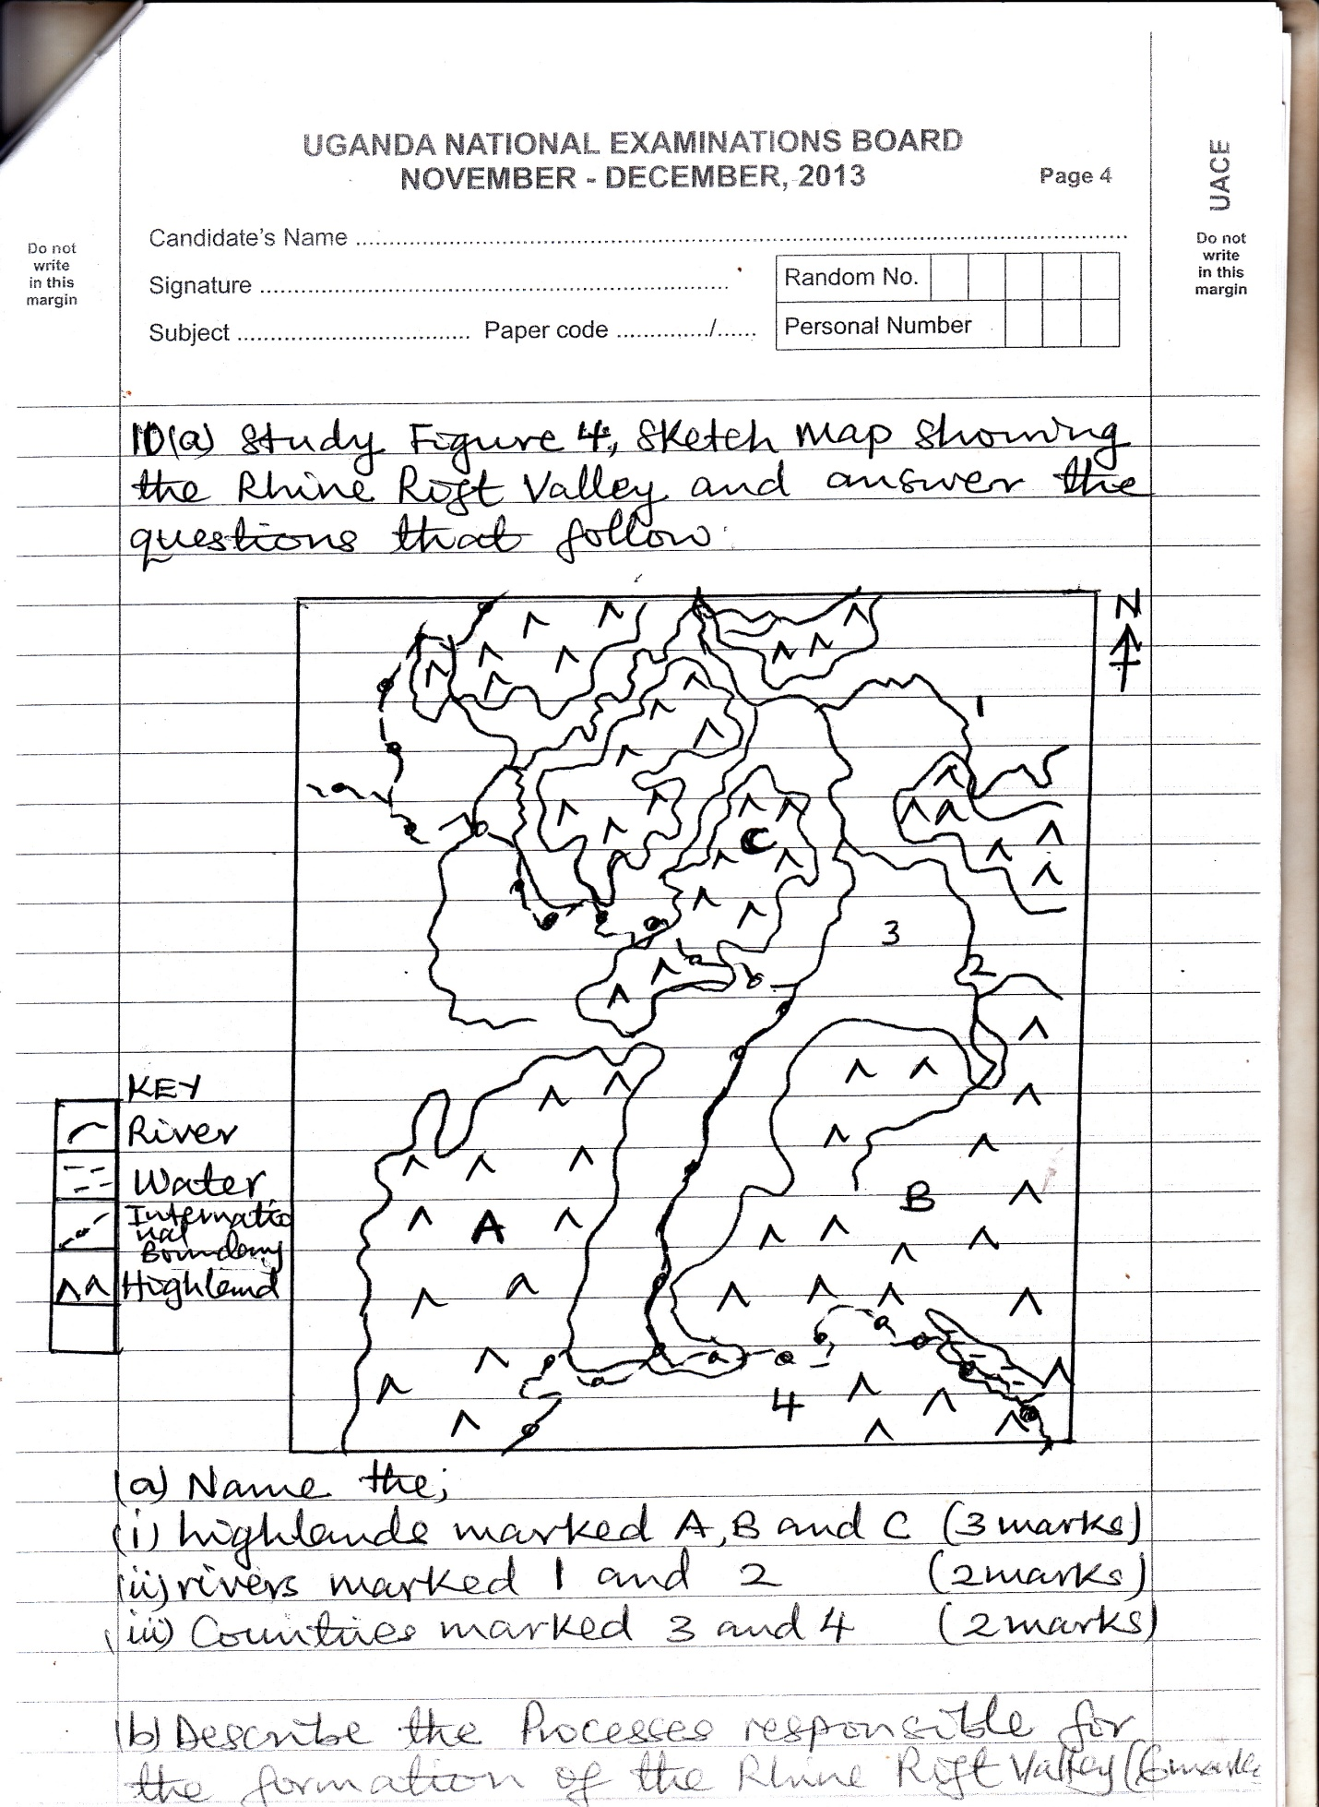

1. Name the;
2. Highlands marked **A, B**  and **C** **(03 marks)**
3. Rivers marked **1**  and **2**  **(02 marks)**
4. Countries marked **3**  and **4** **(02 marks)**
5. Describe the processes responsible for the formation of the Rhine Rift Valley.

**(06 marks)**

1. Explain the influence of relief on land use in the Rhine Rift Valley. **(08 marks)**
2. Outline the problems faced by farmers in the Rhine Rift Valley. **(04 marks)**

**End**